**How to create PDF in docker container in .NET Core**

Syncfusion Essential® PDF is a [.NET Core PDF library](https://www.syncfusion.com/document-processing/pdf-framework/net-core/pdf-library) used to create, read, and edit PDF documents. Using this library, you can create a PDF document in docker using ASP.NET Core.

Steps to create PDF in docker programmatically:

1. Create a new C# ASP.NET Core web application project. 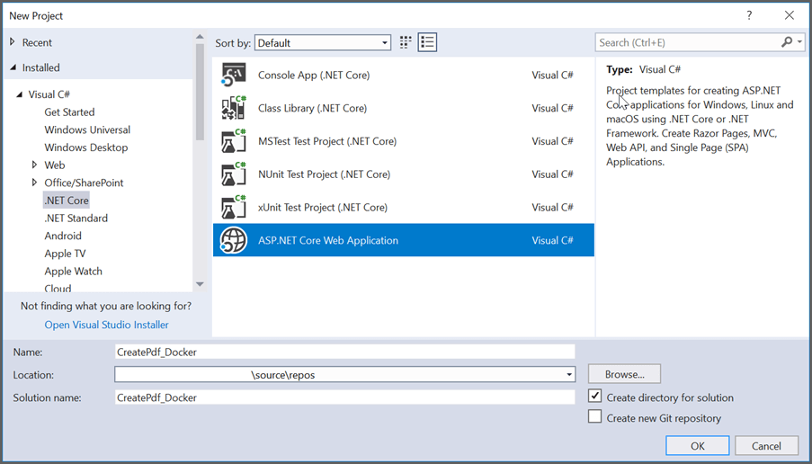
2. Select the project template with Model-View-Controller and enable the docker support. Select the target OS (Windows or Linux) based on the requirement. In this article, Linux has been used as Target OS. 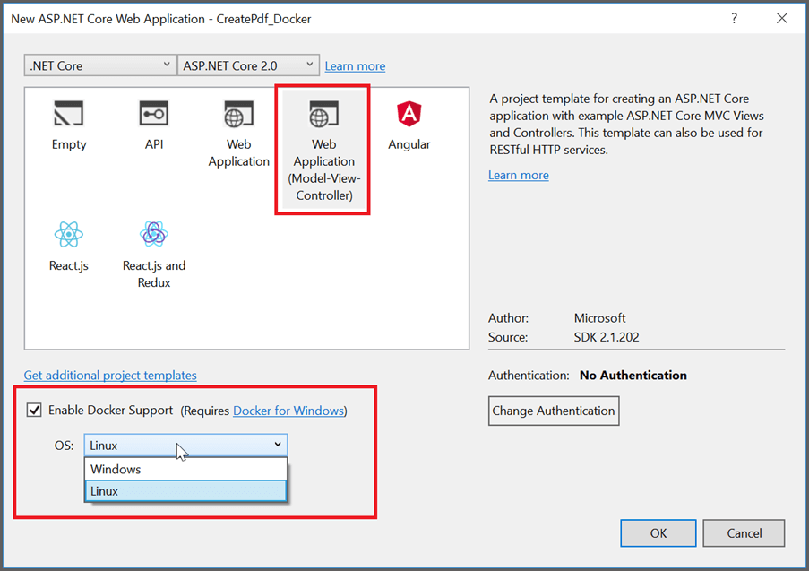
3. Install the [Syncfusion.Pdf.Net.Core](https://www.nuget.org/packages/Syncfusion.Pdf.Net.Core/" \t "_blank) NuGet package as reference to your .NET Core project from [NuGet.org](https://www.nuget.org/). 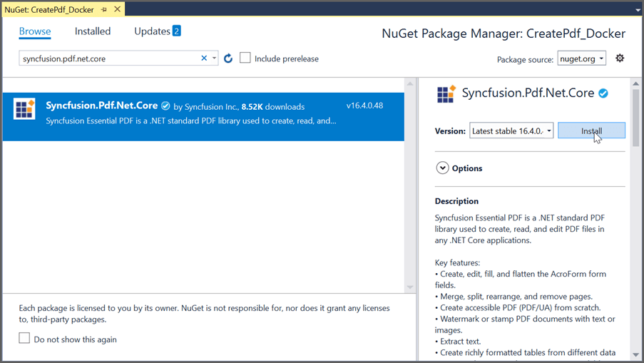
4. Add a new button (Create Document) in the **Index.cshtml** as shown below.

|  |
| --- |
| @{Html.BeginForm("CreateDocument", "Home", FormMethod.Get);  {  <div>       <input type="submit" value="Create Document" style="width:150px; height:27px" />  </div>  }  Html.EndForm();  } |

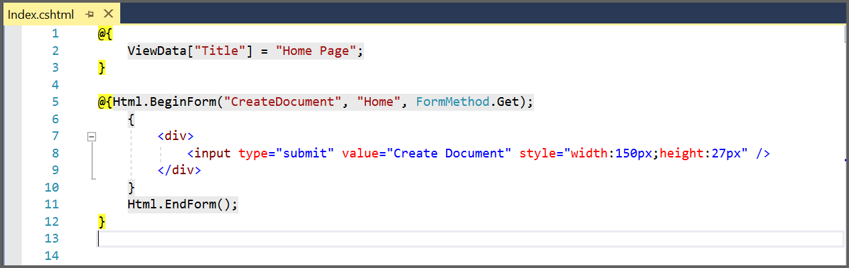

1. Include the following namespaces in the **HomeController.cs** file.

**C#**

**using** Syncfusion.Pdf;

**using** Syncfusion.Pdf.Graphics;

**using** Syncfusion.Drawing;

**using** System.IO;

**VB.NET**

**Imports** Syncfusion.Pdf

**Imports** Syncfusion.Pdf.Graphics

**Imports** Syncfusion.Drawing

**Imports** System.IO

1. Add a new action method **CreateDocument** in **HomeController.cs** and include the following code snippet to create a PDF file and download it.

**C#**

//Create a new PDF document

PdfDocument document = **new** PdfDocument();

//Add a page to the document

PdfPage page = document.Pages.Add();

//Create PDF graphics for the page

PdfGraphics graphics = page.Graphics;

//Set the standard font

PdfFont font = **new** PdfStandardFont(PdfFontFamily.Helvetica, 20);

//Draw the text

graphics.DrawString("Hello World!!!", font, PdfBrushes.Black, new PointF(0, 0));

//Saving the PDF to the MemoryStream

MemoryStream stream = **new** MemoryStream();

document.Save(stream);

//Set the position as '0'

stream.Position = 0;

//Download the PDF document in the browser

FileStreamResult fileStreamResult = **new** FileStreamResult(stream, "application/pdf");

fileStreamResult.FileDownloadName = "Sample.pdf";

return fileStreamResult;

**VB.NET**

'Create a new PDF document

**Dim** document **As** PdfDocument = New PdfDocument

'Add a page to the document

**Dim** page **As** PdfPage = document.Pages.Add

'Create PDF graphics for the page

**Dim** graphics **As** PdfGraphics = page.Graphics

'Set the standard font

**Dim** font **As** PdfFont = New PdfStandardFont(PdfFontFamily.Helvetica, 20)

'Draw the text

graphics.DrawString("Hello World!!!", font, PdfBrushes.Black, New PointF(0, 0))

'Saving the PDF to the MemoryStream

**Dim** stream **As** MemoryStream = New MemoryStream

document.Save(stream)

'Set the position as '0'

stream.Position = 0

'Download the PDF document in the browser

**Dim** fileStreamResult **As** FileStreamResult = New FileStreamResult(stream, "application/pdf")

fileStreamResult.FileDownloadName = "Output.pdf"

**Return** fileStreamResult

1. Build and run the sample in docker. It will pull the Linux docker image from the docker hub and run the project. 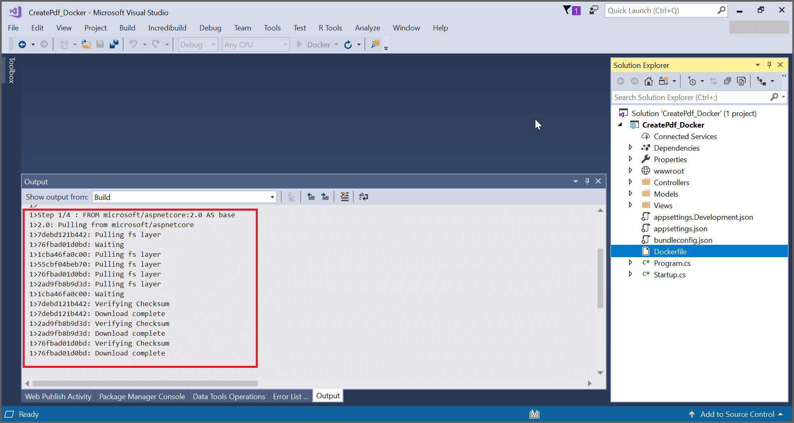
2. It will prompt for accessing the windows drives. Now, the webpage will open in the browser. Click the Create PDF button to create a PDF document in Linux docker container. 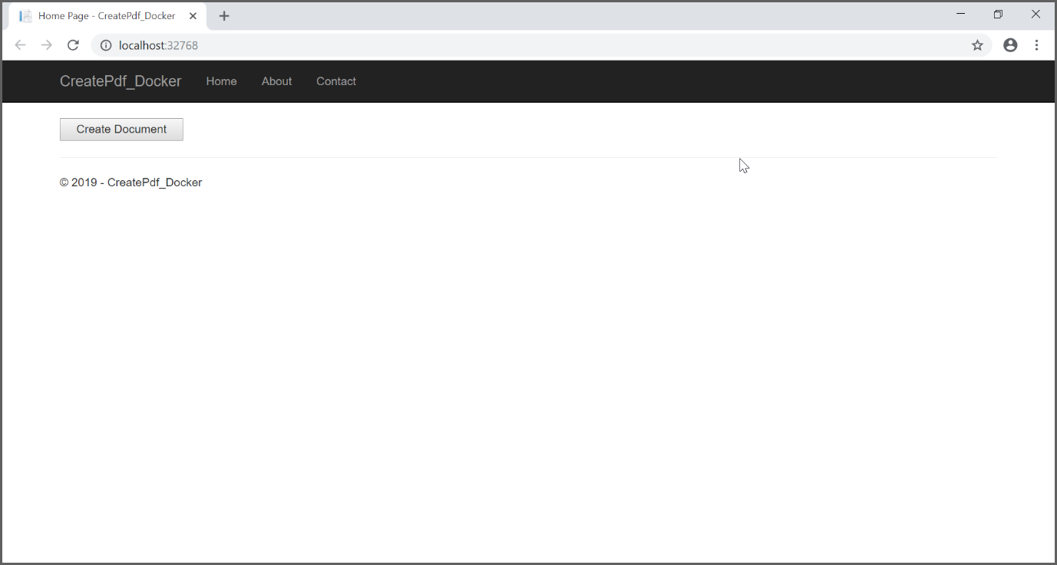

A complete working sample can be downloaded from [CreatePdf\_DockerSample.zip](https://www.syncfusion.com/downloads/support/directtrac/general/ze/CreatePdf_Docker-1372418701)

By executing the program, you will get the PDF document from docker as follows. 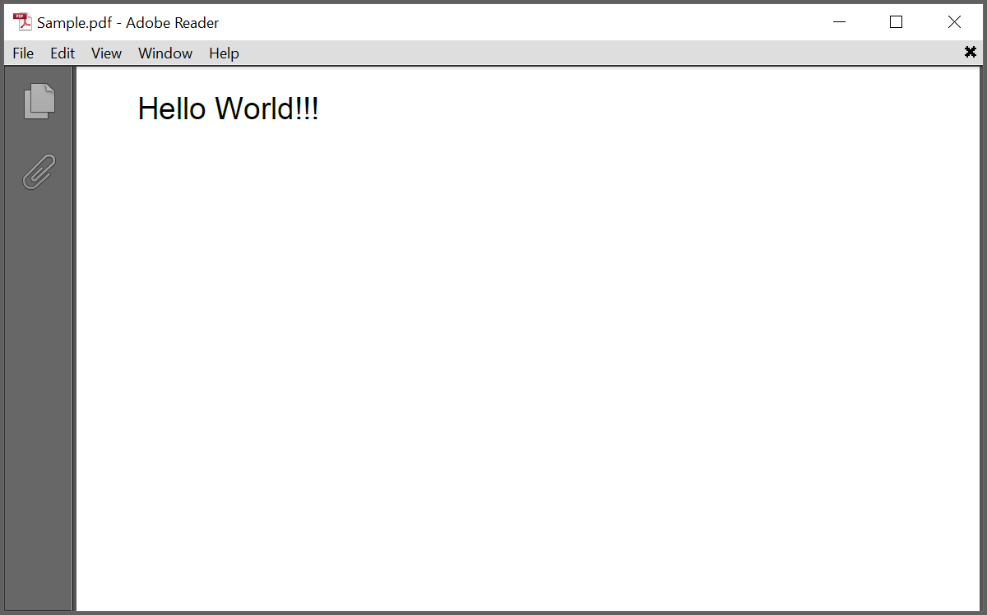

Take a moment to peruse the [documentation](https://help.syncfusion.com/file-formats/pdf/working-with-text), where you will find other options like drawing right-to-left text and multi-column text, consuming TrueType fonts, Standard fonts, and CJK fonts. Also, the features like [PDF form filling](https://help.syncfusion.com/file-formats/pdf/working-with-forms), extract [text](https://help.syncfusion.com/file-formats/pdf/working-with-text-extraction) or [images from PDF](https://help.syncfusion.com/file-formats/pdf/working-with-image-extraction), and [protect PDF documents](https://help.syncfusion.com/file-formats/pdf/working-with-security) with code examples.

Refer [here](https://www.syncfusion.com/document-processing/pdf-framework/net) to explore the rich set of Syncfusion Essential® PDF features.

An online sample link to [generate Hello world PDF document](https://ej2.syncfusion.com/home/aspnetcore.html#platform/pdf/default).

**See Also:**

[Create a PDF file in Xamarin](https://support.syncfusion.com/kb/article/8051/how-to-create-a-pdf-file-in-xamarin)

[Create a PDF file in ASP.NET MVC](https://support.syncfusion.com/kb/article/7963/how-to-create-a-pdf-file-in-asp-net-mvc)

[Create a PDF file in WPF](https://support.syncfusion.com/kb/article/7943/how-to-create-a-pdf-file-in-wpf)

[Create a PDF file in Windows Forms](https://support.syncfusion.com/kb/article/8123/how-to-create-a-pdf-file-in-windows-forms)

Note:

Starting with v16.2.0.x, if you reference Syncfusion® assemblies from trial setup or from the NuGet feed, include a license key in your projects. Refer to [link](https://help.syncfusion.com/common/essential-studio/licensing/overview) to learn about generating and registering Syncfusion® license key in your application to use the components without trail message.

**Conclusion**

I hope you enjoyed learning about how to create PDF in docker container in .NET Core application.

You can refer to our [**.NET PDF Core’s feature tour**](https://www.syncfusion.com/document-processing/pdf-framework/net-core) page to know about its other groundbreaking feature representations and [**documentation**](https://help.syncfusion.com/file-formats/pdf/create-pdf-file-in-asp-net-core), and how to quickly get started for configuration specifications. You can also explore our [**PDF example**](https://www.syncfusion.com/demos/fileformats/pdf-library) to understand how to create and manipulate data in the .NET PDF.

For current customers, you can check out our [**Document processing libraries**](https://www.syncfusion.com/document-processing/pdf-framework/net) from the[**License and Downloads page**](https://www.syncfusion.com/sales/teamlicense). If you are new to Syncfusion®, you can try our 30-day free trial to check out our .NET Core PDF and other .NET Core controls.

If you have any queries or require clarifications, please let us know in the comments section below. You can also contact us through our [**support forums**](https://www.syncfusion.com/forums/37165/welcome-to-the-essential-pdf-asp-net-forum), [**Direct-Trac**](https://support.syncfusion.com/create), or [**feedback portal**](https://www.syncfusion.com/feedback). We are always happy to assist you!